**Cordova包裝HTML5**

Shared by Egg Chen

1. 安裝步驟請參考[http://cordova.apache.org/docs/en/5.0.0//guide_cli_index.md.html#The%20Command-Line%20Interface](http://cordova.apache.org/docs/en/5.0.0/guide_cli_index.md.html" \l "The%20Command-Line%20Interface)
2. 需安裝android sdk
3. Netbeans建立一個cordova專案,並將html所有程式丟到www目錄下,在執行build即可

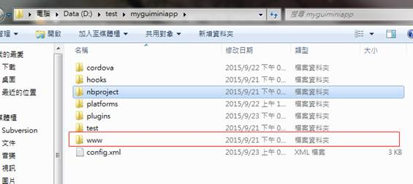

**\*注意在servlet resonse中添加haeader,如下**

**response.addHeader("Access-Control-Allow-Origin", "*");**